Kingdom of Saudi Arabia  Ministry of Education  Eastern Province Education Department  Tarbeat Al-Ajial International Schools |  |  |  |  |  |  | Date: ……/………/..………  Subject: Computer  Grade: G3
……………… |  | Seat Number |  | ……………………………………….. |  |  |  | Student’s Name
2nd Semester Exam (2nd Session) 2025/2026
Sign. | Consultative Name |  | Sign. |  | Corrector’s Name | Marks in letters |  |  | Marks  in numbers
 |  |  |  |  |  |  |  |  | 40
Question A: Match the following
 | Gmail
 | Yahoo
 | Outlook
 | Excel Logo
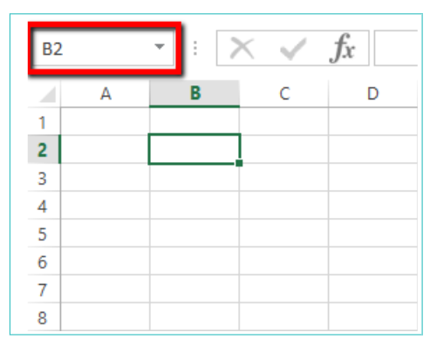 | Spreadsheet

Question C: Write the correct name of each part.
Pictures | Shapes | WordArt | Header & Footer
Check List |  | Menu Card
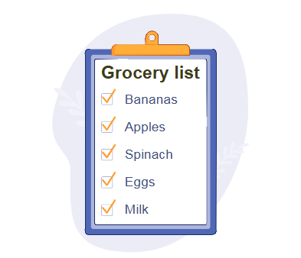





Shapes
Pictures
Check List

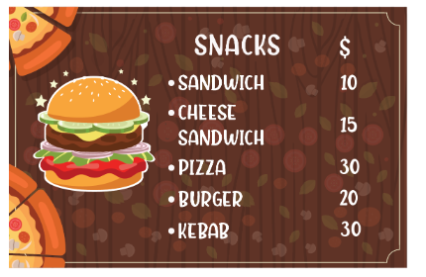

Menu Card
WordArt
Header & Footer

Question B: State whether the statements are ( True / False ).
- The email ID consists of the Email and domain.
- True b. False
- Name is the service provider of the email service.
a. True b. False
- Shape outline is used to apply borders to shapes.
a. True b. False
- Layout option is used to align a picture with text.
a. True b. False
Good Luck
Good Luck

